# **CTF Topic: HTTP**

# **1. Introduction**

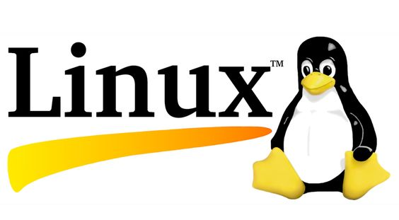

# The Linux operating system's architecture mainly contains some of the components: The Kernel , System libraries

**2. Kernel**

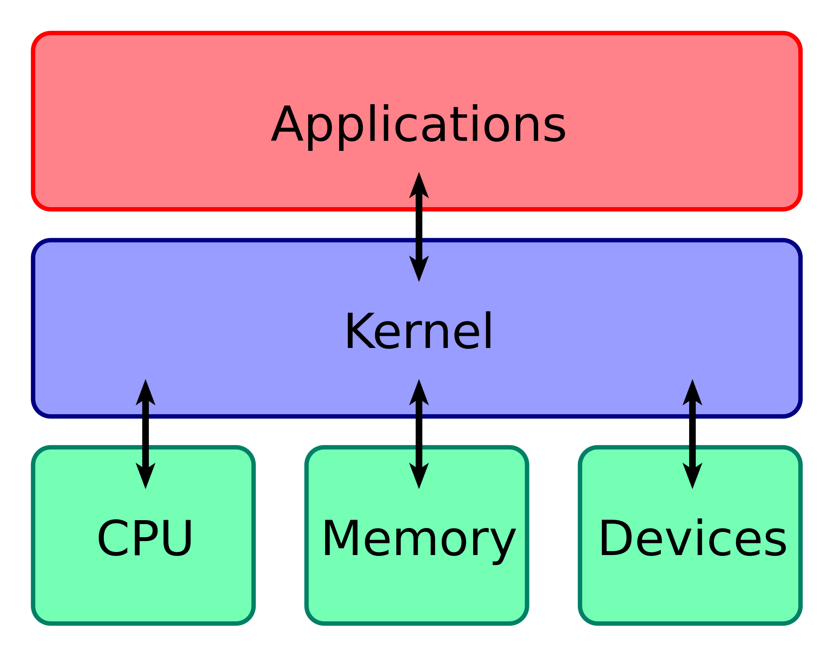

The kernel is the heart of the Linux operating system and has several key responsibilities:The kernel is the heart of the Linux operating system and has several key responsibilities:

**Process Management:**  Core service provider; controls such functions as scheduling, creation, or dismissal. The latter regulates the allotment of the CPU among processes and handles multitasking.

**Memory Management:**  Is responsible for deciding the placement of memory and their removal, optimization of memory space, and protection of memory from other processes.

**Device Drivers:**  It is responsible for the interface between the hardware and the software. It includes the drivers for different hardware components which were installed such as storage devices, network interfaces, I/O devices among others.

**System Calls and Security:** Comprises a list of system calls which applications employ to request services of the kernel and at the same time access these services without compromise to the system assets.

**3. System Libraries**

Like the heart of an organism, system libraries are the parts containing functions necessary for the application to communicate with the kernel. The most common set of system libraries in Linux is the GNU C Library (glibc), which provides:The most common set of system libraries in Linux is the GNU C Library (glibc), which provides:

**Standard Functions:** Implementations of standard functions like printf, malloc, and fopen.

**Hardware Abstraction:**  Utilities to access various hardware with unified interfaces.

**Application Support:** Networking, files to read and write, cryptography, and many other libraries one might need while programming.

**4. System Utilities**

System utilities are designed for operation, maintenance as well as administration of a System. They can be divided into:

**Basic Utilities:** Command-line interfaces are used for displaying files in a directory, cp which is used for copying a file, and ps used for checking the status of a process.

**Administrative Tools:** Commands that have to do with creation of new users and their passwords (useradd, passwd), logging and analyzing system activity (dmesg, syslog), and system settings (ifconfig, iptables).

**Package Managers:**  Software utilization on Debian based systems inclines toward ’apt’ while on Red Hat based systems, it is inclined toward ’yum.’

**5. User Interface**



Linux provides both command-line and graphical user interface:

**Command-Line Interface (CLI):** Some of the interfaces include Bash, Zsh and other shells where user type courses through text commands with the system. It is best suited for ‘scripting’, automation tasks, and for executing large numbers of tasks within a relatively short amount of time.

**Graphical User Interface (GUI):** Most systems like GNOME, KDE, Xfce and so on offer windowing systems to present graphics and structures such as windows, icons and menus to allow users a graphical interface for use instead of the command line interface.

### 

### 

### 6. Application Programs

Linux supports a wide range of applications that run on top of the kernel and system libraries:

**Text Editors**: Examples include Vim, Emacs, and Nano for editing text files.

**Web Browsers**: Firefox, Chrome, and other browsers for web access.

**Office Suites**: LibreOffice and similar applications for productivity tasks.

**Development Tools**: Compilers (GCC), interpreters (Python), and IDEs (Eclipse).

**Servers**: Apache, Nginx, and MySQL for running web and database servers.

# 

# 

# 

# **Let’s start the Challenge**

# **Question**

**Flag 1 :** What does process management fall under

**Answer :** Kernel

**Flag 2 :** What does Administrative Tools fall under

**Answer :** System Utilities

**Flag 3 :** What does Text Editors fall under

**Answer :** Application Programs